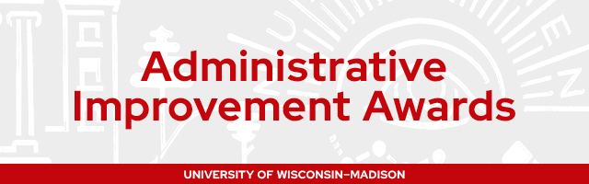
AIA Nomination Form
Criteria for Eligibility All current academic staff, university staff, faculty, limited employees, and student employees are eligible for the award. Individuals and teams may be nominated. Self-nominations will only be accepted with supervisor/manager approval.
☐Check the box if your project completed on or after January 1, 2026
☐Check the box if you are nominating someone else
☐Check the box if you are nominating yourself
If this is a self-nominated project, please fill out the below information
Supervisor/manager name Supervisor/manager email address

Project Name
This is how the project will be referenced in communications about AIA nominees and recipients.

Start typing your response here.

Name of Project Sponsor
If known, please include the name of the project sponsor. A sponsor is the leader who authorizes the project and is ultimately responsible for ensuring the project reaches it goals. The sponsor gives the project credibility, opens up funding and resources, and may attend select meetings with those involved with the project.

Start typing your response here.

Name of Team Members
Include the name of all team members and their email address in the table below. Add additional rows as necessary.
Employee First Name, Last Name | Email Address

Project Outcome Category
You may select as many as apply:
☐Surpassing customer expectations
☐Driving strategic direction
☐Process improvement
☐Product/service enhancement
☐Improved efficiency
☐Increased revenue channels or cost savings

Project Objective (300 words or less)
Briefly describe the situation before the project was initiated or the problem/opportunity that led to the initiation of the project. What was the problem the project was trying to solve?

Start typing your response here.

Changes or Improvements (300 words or less)
Describe what actions were taken to address the problem or challenge detailed above, including:
- Method or steps taken to achieve changes/improvements
- Innovative or creative approaches used

Start typing your response here.
Results (300 words or less)
Describe key achievements and outcomes of the project (e.g., improved efficiency, improved service delivery, increased revenue channels, cost savings, etc.), including:
- Direct outputs or outcomes of the changes and improvements
- Positive impact on customers, end-users, including the unit/division or university as a whole
- Quantitative "before" and "after" data, if available
- Qualitative data such as testimonials, if available

Start typing your response here.

Connection to Mission (300 words or less)
Describe how this project helps to advance the university’s mission and if this project is connected to a strategic plan, please explain.

Start typing your response here.

Next Steps
Describe where the work goes from here, such as:
- Steps that have been taken to ensure that the achievements are sustained
- How the project outcomes might contribute to ongoing improvements and future initiatives

Start typing your response here.

Submit Your Nomination
Nominations must be emailed to adminimprove@vc.wisc.edu.
The deadline for nominations is Friday, February 5, 2027.
Remember to include relevant supporting materials including visuals, graphs, or data sets. These materials can be attached to this document or uploaded separately.

